Phys 629 Homework #1 Fluid Properties

Name:

### Density

1) A tank contains 500 kg of a liquid whose specific gravity is 2. Determine (a) the specific weight of the liquid and (b) the volume of the liquid in the tank.

### Compressibility

2) The bulk modulus for seawater is 2.34×109 N/m2. Estimate the increase in pressure required to decrease a unit volume of seawater by 0.5%.

### Viscosity

3) For a parallel plate arrangement of the type shown in the following figure, it is found that when the distance between the two plates is 2 mm, a shearing stress of 150 Pa develops at the upper plate when it is pulled at a velocity of 1 m/s. Determine the viscosity of the fluid between the plates.

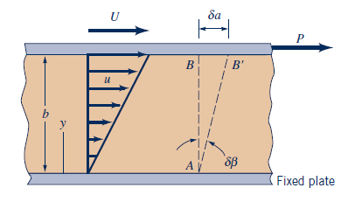

### Surface Tension

4) When a 2-mm-diameter tube is inserted into a liquid in an open tank, the liquid is observed to rise 10 mm above the free surface of the liquid. The contact angle between the liquid and the tube is zero, and the specific weight of the liquid is 1.2×104 N/m3. Determine the value of the surface tension for this liquid.