**Phys 629 Homework #2 Fluid Statics**

Name:

### Pressure Variation in a Fluid at Rest

1. A closed, 5-m-tall tank is filled with water to a depth of 4 m. The top portion of the tank is filled with air which, as indicated by a pressure gage at the top of the tank, is at a pressure of 20 kPa. Determine the pressure that the water exerts on the bottom of the tank.

### Pressure Measurement, Manometer, and U-Tubes

1. In the following figure, pipe A contains gasoline (SG = 0.7), pipe B contains oil (SG = 0.9), and the manometer fluid is mercury (SG = 13.6). The initial differential reading is 0.30 m as shown. Determine the new differential reading if the pressure in pipe A is decreased 25 kPa, and the pressure in pipe B remains constant.

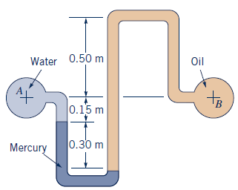

1. A piston having a cross-sectional area of 0.05 m2 is located in a cylinder containing water as shown in the following figure. An open U-tube manometer is connected to the cylinder as shown. For h1= 50 mm and h = 100 mm, what is the value of the applied force, P, acting on the piston? The weight of the piston is negligible. The specific gravity for mercury is 13.6.

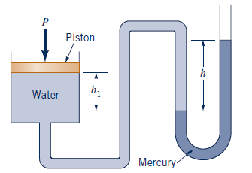

### Buoyancy

1. An irregularly shaped piece of a solid material weighs 10 N in air and 8 N when completely submerged in water. Determine the density of the material.

### Pressure Variation in Rigid-Body Motion

1. The open U-tube is partially filled with a liquid. When this device is accelerated with a horizontal acceleration *a*, a differential reading h = 2.5 cm develops between the manometer legs which are spaced a distance apart, *l* = 5 cm. Determine the acceleration of a.

