**Phys 629 Homework #3 Bernoulli Equation & Fluid Kinematics**

Name:

### Bernoulli Equation

1. Determine the flowrate through the pipe. (flowrate *Q* = *AV*)

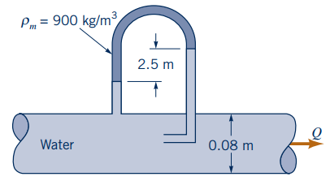

1. Oil of specific gravity 0.83 flows in the pipe shown in the following figure. If viscous effects are neglected, what is the flowrate? (1 in = 2.54 cm)

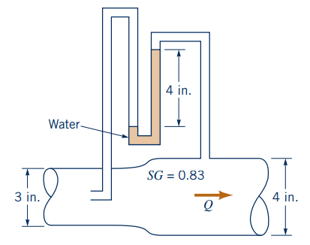

### Material Derivative

1. A gas flows along the x-axis with a speed of *V* = 5*x* m/s and a pressure of *p* = 10*x*2 Pa, where *x* is in meters. (a) Determine the time rate of change of pressure at the fixed location *x* = 1. (b) Determine the time rate of change of pressure for a fluid particle flowing past *x* = 1. (c) Explain why the answers to parts (a) and (b) are different.

### Reynolds Transport Theorem

1. At time *t* = 0 the valve on an initially empty (perfect vacuum, *ρ* = 0) tank is opened and air rushes in. If the tank has a volume of *~~V~~0* and the density of air within the tank increases as *ρ* = *ρ*0(1-*e-bt*), where b is a constant, determine the time rate of change of mass within the tank.